READ CAREFULLY

CHILD ACTIVITIES (refers to under 18 years of age)

PARENT/GUARDIAN CONSENT, ACKNOWLEDGEMENT OF RISK, WAIVER, RELEASE AND INDEMNITY

Please complete form, sign and submit the original copy to Foundation staff

2181 Queen Foundation

Note: All references herein to the 2181 Queen Foundation include the Foundation, the owner of the building, any society or association involved in the operation of and/or provision of programs or services at the building or for the Foundation and all of their respective officials, directors, officers, employees, volunteers and agents. Anyone under 18 years of age - infant, child or youth - or anyone over such age under legal disability - is defined as Child for the purposes of this agreement.

Activity Name: |  |  | Date |  |  |  | Time

Activity Description:

See attached

Mode of Transportation: |  | Not applicable
Child's Name: |  |  |  | Parent/Legal Guardian Name:

NOTICE TO PARENT/GUARDIAN

It is a condition to the Child's participation in the Activity that you, the undersigned Parent/Guardian of the Child, must carefully read and understand this document and sign it to acknowledge that you have read and understand it and that you understand that the Child's participation in the activity may expose the Child to risks of harm and that you accept full responsibility for exposing the Child to such risks.

PARENT/GUARDIAN RESPONSIBILITY FOR CHILD

I, the undersigned Parent/Guardian of the Child, understand and accept that, in respect of the Child's participation in the Activity, it is my responsibility (1) to ensure that I consider and understand the risks, dangers, hazards and consequences of injury inherent in the Activity,

- to determine, taking into consideration those risks and the Child's behavioural characteristics, physical health and abilities, whether the Child should be allowed to participate in the Activity, (3) to ensure that the Child is appropriately covered by medical insurance for any harm occurring in the Activity, and (4) to provide emergency medical information regarding the Child as required in this document.

AWARE OF RISKS

I AM AWARE OF AND NOW FREELY ACCEPT AND ASSUME FOR ME AND THE CHILD RESPONSIBILITY FOR ALL RISKS TO THE CHILD IN CONNECTION WITH HIS OR HER PARTICIPATION IN THE ACTIVITY, INCLUDING AS FOLLOWS:
- the Child's participation in the Activity, even if the Child possesses behavioural characteristics, physical health and abilities appropriate for the Activity, poses risks of harm to the Child;
- the nature of the Activity is such that the Foundation cannot identify all risks associated with the Activity and cannot guarantee that Foundation staff participating in the Activity will not make errors therein or that other children participating in the activities will not cause injuries therein to others that staff can or might be able to prevent.

I, THE UNDERSIGNED PARENT/GUARDIAN, AM THE PARENT AND/OR LEGAL GUARDIAN OF THE CHILD AND FOR THE CHILD I HEREBY CONSENT TO HIM OR HER PARTICIPATING IN THE ACTIVITY, AND, FOR MYSELF AND THE CHILD, IN RETURN FOR THE FOUNDATION ALLOWING THE CHILD TO PARTICIPATE IN THE ACTIVITY:

- I NOW WAIVE ALL LEGAL RIGHTS TO ANY AND ALL CLAIMS which I or the Child or our respective heirs, executors, successors and assigns may have against the Foundation in connection with any loss, injury, damage or expense that I or the Child may suffer, incur or may suffer, incur or experience in connection with the Child's participation in the Activity; and
- I HEREBY ACKNOWLEDGE that the organization which operates and supervises the Activity is the party legally responsible for the Activity and not the Foundation.
- I HEREBY RELEASE the Foundation from any and all liability for any complaints, demands, claims, actions, suits, judgments and orders for any and all losses, injuries, damage or expenses I or the Child may suffer, incur or experience in connection with the Child's participation in the Activity; and

- FOR MYSELF, I AGREE TO INDEMNIFY the Foundation for and hold it harmless from any and all losses, injuries, damages and expenses of any kind that the Foundation may suffer, incur or experience and for any and all complaints, demands, claims, actions, suits, judgments and orders for any and all losses, injuries, damages or expenses of any kind anyone else may suffer, incur or experience in connection with the Child's participation in the Activity.

EMERGENCY INFORMATION AND MEDICAL CONSENT

I hereby authorize the Community Centre, in the event of an apprehended emergency, to administer first aid to the Child and transport or arrange emergency transportation of the Child to a medical facility for medical treatment.

Child's Name:

Child's Health Care Card Number:

Child's Date of Birth: (mm/dd/yyyy)

Emergency Contacts:

Name:

Name:

Relation to Child:

Relation to Child:

Phone:

Phone:

Phone:

Phone:

List any Medical or behavioural concerns staff should be aware of. Please include allergies, life threatening conditions, disabilities, or if extra assistance is required. This information helps staff determine if we can reasonably accommodate your child.

PICK-UP PERMISSION :

I understand it is my responsibility to communicate to Foundation staff any special instructions necessary in respect of the pick up of my child.

PERMISSION TO UTILIZE PHOTOS AND TESTIMONIALS:

I hereby authorize the Foundation to photograph and/or otherwise record images and/or sounds of or including the Child while he or she participates in the activities described above and to freely publish and otherwise make use of as it wishes, without compensation to the Child or anyone else, all such photographic images and other recordings of the Child for purposes of documenting and promoting Foundation programs and services.

Examples include: use in program brochures, on photo displays, and through Foundation social media such as web posting and video. I understand that names or any other information regarding the identification of the Child would require additional consent.

YES | NO

In signing this document and permitting the Child to participate in the Activity, I do not rely upon any oral or written statements, promises or other communications made by the Foundation other than that set out in this document. This document will be exclusively governed by and interpreted in accordance with the laws of Ontario and no court outside of Ontario will have any jurisdiction over this Consent, the Activity, or any of the matters arising from them.

I HAVE READ AND I UNDERSTAND THIS DOCUMENT
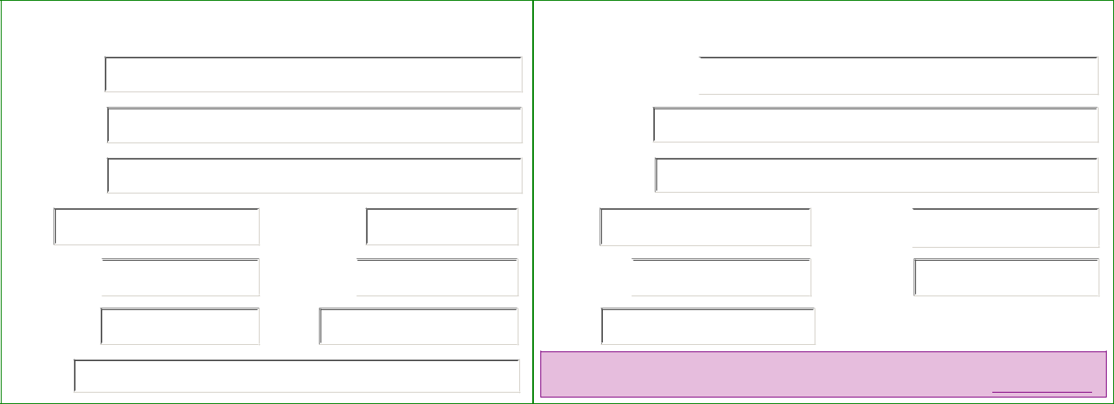

PARENT/LEGAL GUARDIAN

PARTICIPANT CHILD/YOUTH

Signature:

Print Name:

Address:

City:

Home Phone:

Cell Phone:

Postal Code:

Work Phone:

Date:

Signature (preferred):

Print Name:

Address:

City:

Home Phone:

Date:

Postal Code:

Cell Phone:

Email:
Reviewed for Completeness by Staff - Initials:

